EXPT NO:2 | Implementation of data visualization techniques
DATE: 06.01.2026 | Implementation of data visualization techniques

PRE-LAB QUESTIONS (PROVIDE BRIEF ANSWERS TO THE FOLLOWING QUESTIONS)
- Why is exploratory data analysis critical before model building?
Ans - EDA helps understand data patterns, quality, and issues before building accurate models.
- How do distributions influence algorithm selection in ML?
Ans - Data distribution affects which algorithms perform better and whether normalization is needed.
- What insights can outliers provide in business data?
Ans - Outliers can indicate high-value customers, errors, or unusual business events.
- Why are visual summaries preferred over raw tables?
Ans - Visuals make patterns and trends easier to understand than raw numbers.
- How does visualization improve business intelligence?
Ans - Visualization helps quickly identify trends, risks, and opportunities for better decisions.
IN-LAB EXERCISE:

OBJECTIVE:
To explore data distribution and variability using advanced visualization techniques.

SCENARIO:
A startup analyzes e-commerce transaction data to understand customer spending behavior and detect abnormal purchase patterns.

IN-LAB TASKS (Using R Language)
- Plot histogram of transaction amounts
- Use boxplot to detect outliers
- Create heatmap of monthly sales intensity

(CODE: CONATAINS STUDENT ROLL NOS
SCREENSHOT OF CODE
SCREENSHOT OF OUTPUT)
CODE:
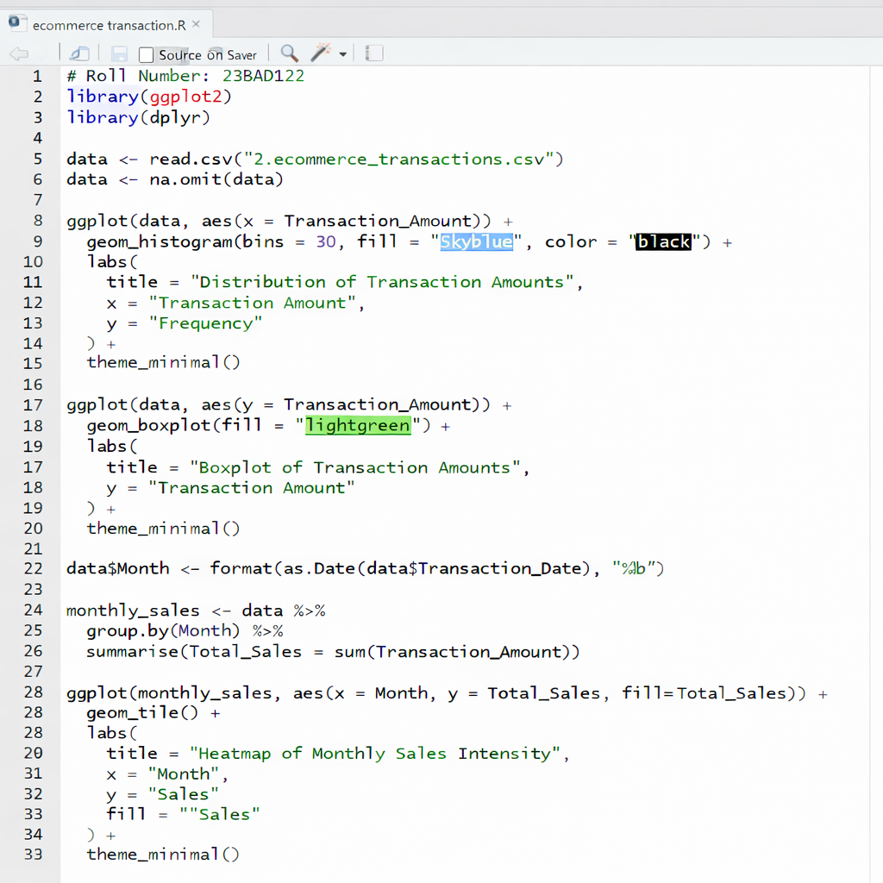

OUTPUT:

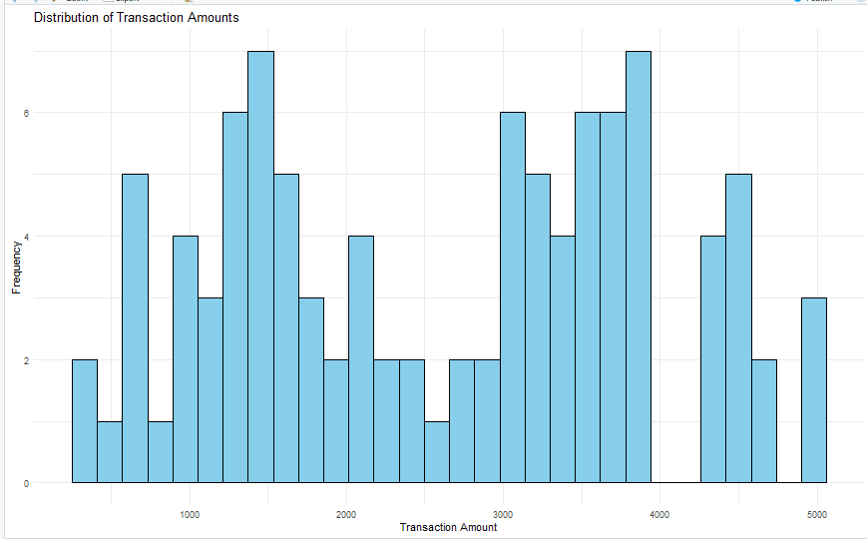

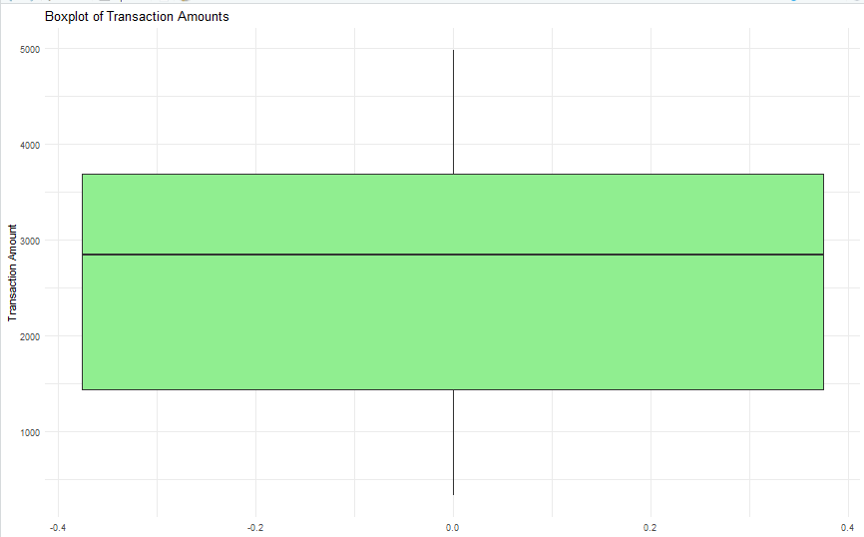

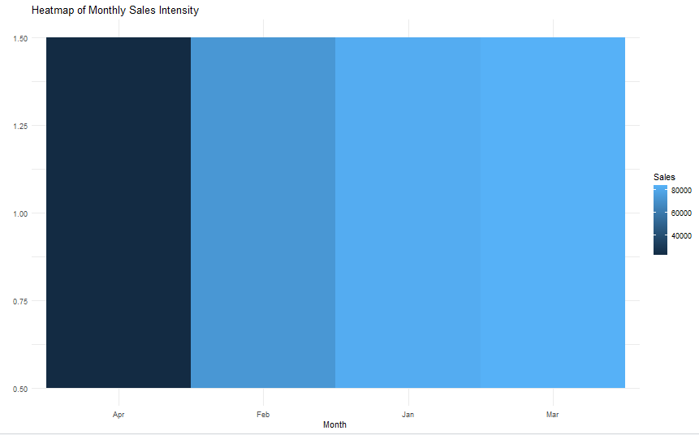

POST-LAB QUESTIONS (PROVIDE BRIEF ANSWERS TO THE FOLLOWING QUESTIONS)

- What does right-skewed distribution indicate about customer behavior?
Ans - The histogram shows a right-skewed distribution, meaning most customers make low to medium purchases, while a few make very high-value purchases.

- How can detected outliers impact business decisions?
Ans - The boxplot shows wide variability in transaction amounts and indicates the presence of high-value transactions.

- Which visualization best supports anomaly detection?
Ans - January and March show higher sales intensity, while April shows comparatively lower sales.

- How does EDA improve AI model accuracy?
Ans - The boxplot highlights unusually high transaction amounts, and the histogram shows rare high-value purchases clearly.

- How can visualization guide feature engineering?
Ans - It helps identify common spending ranges, peak sales months, and unusual high-value transactions for better business decisions.

ASSESSMENT
Description | Max Marks | Marks Awarded
Pre Lab Exercise | 5
In Lab Exercise | 10
Post Lab Exercise | 5
Viva | 10
Total | 30
Faculty Signature

